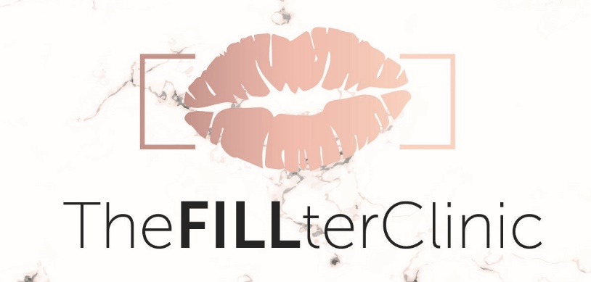

Price List

Dermal Filler Treatment
Lip Augmentation- £190
Facial Fillers
Cheek Volumisation/Definition- From £220
Marionette Lines- From £200
Nasolabial Folds- From £200
Non-Surgical Rhinoplasty- £280
Jaw – From £220
Chin Filler- £260
Tear Trough Treatment- £260
Temple Filler/Brow lift, Forehead Filler, Glabellar Filler- From £250
Hand Filler- £300

Polynucleotides
£450-(This includes 3x treatments 3-4 weeks apart) then £200 per session every 6 months after for maintenence

Profhilo Treatment
£400 (Includes 2 x treatments)

Dermal Filler Packages
Filler Dissolving only- £150
Filler dissolve and refill lip package- £280
Mid/Lower face refresh package (Either lips, cheeks, marionette lines or nasolabial folds) 2ml- £390 3ml-£550 4ml- £650
Lips & Nose package- £400
Profile balancing package (chin & nose)- £450
Chin & Jaw package – From £480
4ml contour package (this package can be personalised to suit your needs) -£650
5ml contour package (this package can be personalised to suit your needs) -£800
Each package is tailored to the individual and depending on your concerns/ needs we can create the perfect package for you
Ask about our unique & tailored bridal packages we can offer you

Anti-Wrinkle Injections (Botox) Treatment
1 Area- £150
2 Areas- £190
3 Areas- £210
Additional areas- £60 each

Jawline Slimming/Jaw clenching- £220
Hyperhydrosis (excessive sweating)- £260
Nefertiti Neck Lift- £260

Luxury Dermaplaning Facial Treatment - £40

Prescription only eyelash serum- From £50
WOW Facial (Full 6 stages Including-Cleanse, Peel, WOW fusion (microneedling), LED light therapy, sheet mask & WOW serums/SPF.
From £150

WOW Mini Facials (Includes Pregnancy safe, acne, Glow up) Enquire for a unique tailored facial to suit your skin type
£50

Skin Peels
£30- 1 peel
£50- 3 peels
£70- 4 peels

Luxury Microneedling (Includes tailored mesotherapy cocktails and luxury collagen & peptide sheet mask)
£130- 1 session
£340- 3 sessions
£700- 6 sessions

Obagi™ Medical Grade Skincare Consultation
FREE (Skincare prices to be discussed at consultation)
We can create a skincare package tailored to suit you and your skin type/concerns.

Fat dissolving injections (chin & stomach)
£120

